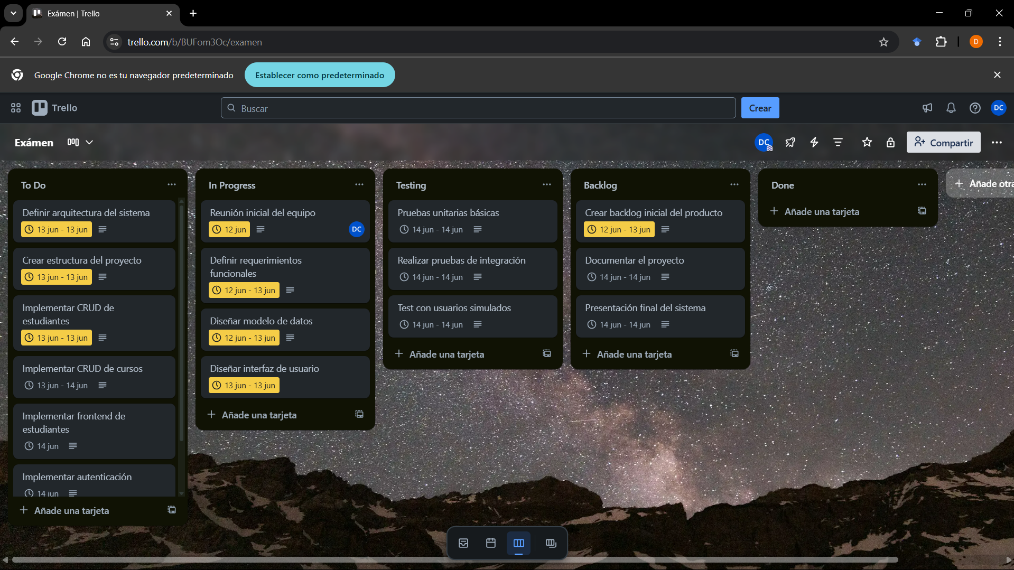

Se movieron 3 tareas de TO DO a IN PROGRESS